Image Recognition Web Application

CS7313 - Advanced Machine Learning and Pattern Recognition, Fall 2020

Sharmila Kanthaiya Srinivasan

**Introduction:**

Let's start by thinking about how important vision can be. Image is the highest band sense, and it provides a vast set of information about the state of the world and acts on it. Based on this, computer vision has born. The goal of computer vision is the ability to extract high-level understanding from digital images and video. We all know that computers and smartphones are good at taking pictures. But can it see or recognize the image?

Images are stored as big grids of pixels on the computer. Each pixel is defined by color and kept as a combination of Red, Green, Blue. The variety of these three colors on different intensities (RGB value) will give any shade. The computer can see the image via a machine learning algorithm. The picture looks like an array of integer values based on the intensities across the color spectrum to an algorithm.

The evolution of machine learning, deep learning, and neural networks created a great revolution in this field. In recent years, computer vision has widened the tasks related to detecting and labeling objects.

**Project Objective:**

This project aims to create a web application that can evaluate images and videos to perform image recognition. The application is based on the data and machine learning model. Given an image or video, the application would recognize the person's facial structure, gender, age, and objects. This process involves various steps like grayscale conversion, face/object cropping, eigen image creation, training machine learning model, and prediction analysis.

**Application Components:**

* **Machine Learning Model:**

1. **Image processing:** Image processing is a method to perform some operations on an image, to extract useful information from it using OpenCV and NumPy.

1.1 **OpenCV:** Open Source Computer Vision Library is an open-source computer vision and machine learning software library.

1.2 **NumPy:** NumPy stands for Numerical Python. It is an open-source module of Python which provides fast mathematical computation on arrays and matrices.

1. **Analysis and Preprocessing:** Image analysis and preprocessing will help apply some transformations to the image to convert raw data into a clean data set.

2.1 **Pandas:** Pandas is a fast, powerful, flexible, and easy to use open-source data analysis and manipulation tool, built on top of the [Python](https://www.python.org/) programming language.

2.2 **Matplotlib:** Matplotlib is a visualization library in Python for 2D plots of arrays.

1. **Scikit Learn:** Scikit-learn is a Python module for machine learning models.

* **Website:**

1. **Web Framework:** Flask
2. **Frontend:** HTML, CSS, and JavaScript.

**Pipeline to analyze image and video:**

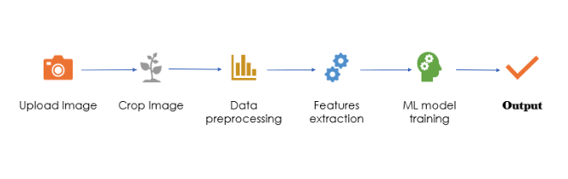

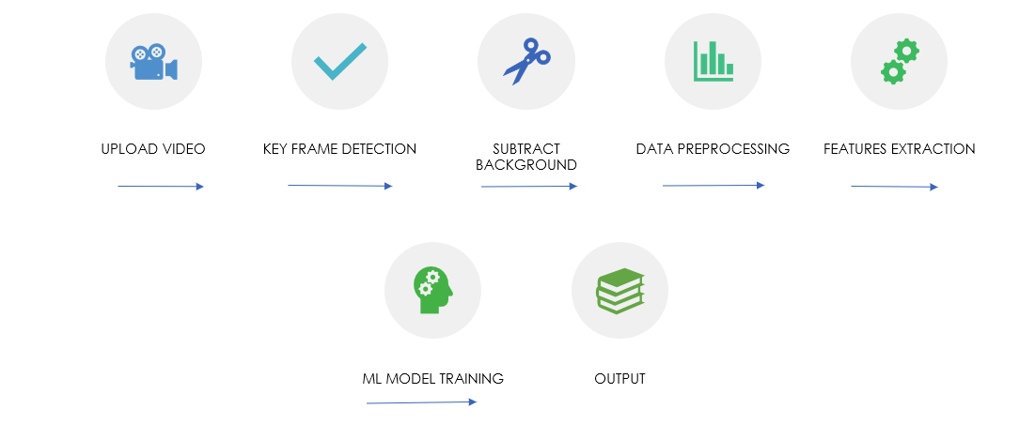

**References:**

* Ross Girshick, Jeff Donahue, Trevor Darrell, and Jitendra Malik. Rich feature hierarchies for accurate object detection and semantic segmentation. *In IEEE Conference on Computer Vision and Pattern Recognition, 2014.*
* Ross Girshick. Fast r-cnn. *In IEEE Conference on Computer Vision and Pattern Recognition, 2015.*